**BIG DATA ANALYSIS WITH IBM CLOUD DATABASES**

**Abstract:**

Big data is a collection of massive and complex data sets and data volume that include the huge quantities of data, data management capabilities, social media analytics and real-time data. Big data analytics is the process of examining large amounts of data.

The dataset of annual surface temperature is a significant component of the broader domain of big data, which encompasses vast and intricate data collections characterized by substantial data volume. This specific dataset pertains to the annual variations in surface temperature across different geographical locations. It plays a critical role in climate science, environmental research, and various applications in sectors such as agriculture, energy, and urban planning.

The dataset consists of extensive records of temperature measurements obtained from various sources, including weather stations, satellites, and remote sensing technologies. These measurements are collected at regular intervals, typically on an annual basis, and cover a broad spectrum of spatial and temporal scales. The dataset spans multiple years or decades, enabling researchers to examine long-term trends and patterns in surface temperature.

**Objectives:**

The primary objective of this project is to harness the potential of extensive datasets to derive valuable insights encompassing a wide spectrum of domains, including climate trends and social patterns. This undertaking entails several key components:

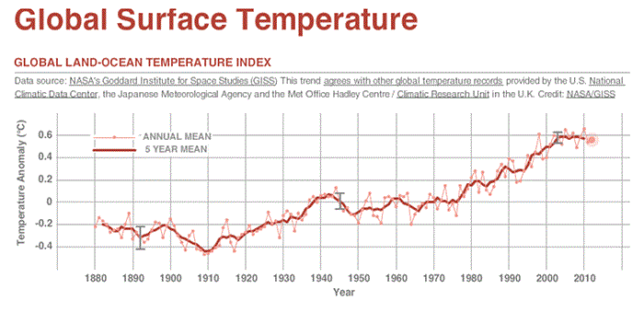

1. **Designing the Analysis Process:**

Develop a comprehensive framework for data analysis, encompassing data collection, preprocessing, feature engineering, and the selection of appropriate analytical techniques tailored to the specific characteristics of the datasets.

1. **Setting up IBM Cloud Databases**:

Establish and configure IBM Cloud databases to efficiently store and manage the vast datasets, ensuring data integrity, security, and accessibility for analysis.

1. **Performing Data Analysis:**

Employ advanced data analysis methods, including statistical analysis, machine learning, and data mining, to uncover hidden patterns, trends, and correlations within the datasets. This includes exploring climate data for long-term trends and investigating social data for behavioral and demographic patterns.

1. **Visualizing the Results:**

Create informative and intuitive data visualizations to present the extracted insights, making them accessible and understandable for stakeholders. Visualization tools and techniques will be utilized to communicate findings effectively.

1. **Business Intelligence:**

Utilize the insights gained from the analysis to drive data-informed decision-making, strategic planning, and operational enhancements in various sectors. The project aims to deliver actionable recommendations and contribute to better-informed business strategies and policies.

The overarching goal is to leverage the power of data analytics and the IBM Cloud platform to unlock meaningful insights from large and complex datasets, enabling organizations to make data-driven decisions, optimize processes, and adapt to changing environmental and social conditions.

**Design Thinking:**

Detailed Design Thinking for Big Data Analytics of Annual Surface Temperature Dataset:

**1. Data Selection:**

* Identify the relevant datasets: This step involves collecting annual surface temperature data from various sources, such as weather stations, satellites, and climate models. Ensure that the data covers a diverse geographical range and spans multiple years for comprehensive analysis.
* Data Quality Assurance: Perform data quality checks to eliminate outliers, correct missing values, and harmonize data from different sources. This ensures that the dataset is of high quality and integrity.

**2. Database Setup:**

* IBM Cloud Databases: Establish an IBM Cloud Database to securely store and manage the extensive temperature dataset. Configure the database for efficient data retrieval and storage.
* Schema Design: Define a well-structured database schema that accommodates the dataset's structure, including attributes like location, date, and temperature values. Ensure scalability to handle the large volume of data.

**3. Data Exploration:**

* Query Development: Develop SQL or NoSQL queries to explore the dataset, allowing for easy data retrieval and manipulation.
* Data Profiling: Conduct data profiling to understand the distribution of temperature values, identify trends, and detect potential data issues. This step provides a foundation for further analysis.
* Metadata: Document metadata information about the dataset, including data sources, collection methods, and any transformations applied. This information aids in data transparency and understanding.

**4. Analysis Techniques:**

* Climate Trends Analysis: Implement time series analysis techniques to identify long-term climate trends, temperature anomalies, and seasonal patterns. Utilize statistical methods and climate models to assess temperature changes and their potential impacts.
* Social Patterns Analysis: For social data integration, apply sentiment analysis, clustering, and regression analysis to understand user sentiment, engagement patterns, and demographics. Identify social factors influencing discussions on surface temperature.

**5. Visualization:**

* Custom Visualizations: Create custom visualizations that effectively convey temperature trends, anomalies, and insights. Use line charts, heatmaps, and geographic maps to visualize temperature variations across different regions.
* Interactive Dashboards: Develop interactive dashboards using visualization tools like Tableau or D3.js to allow users to explore and interact with the data. These dashboards can offer a holistic view of temperature data and related social patterns.

**6. Business Insights:**

* Interpretation: Analyze the findings in the context of the project's objectives, considering the interplay between climate data and social patterns. Identify correlations, potential drivers, and noteworthy events.
* Business Intelligence: Derive valuable business intelligence, such as identifying regions most affected by temperature changes, understanding public sentiment, and providing recommendations for climate resilience strategies or social campaigns.
* Decision Support: Offer actionable recommendations and insights for decision-makers in sectors like agriculture, urban planning, and energy management. Highlight the significance of data-informed decision-making to address climate-related challenges.

**Detailed plan:**

**Week 1-2: Project Initiation**

* Define clear project objectives and scope.
* Formulate a project team and assign roles.
* Identify key stakeholders and their expectations.
* Create a preliminary project timeline and budget.

**Week 3-4: Data Selection**

* Identify and gather relevant datasets for analysis.
* Assess data sources and quality.
* Ensure data compliance and legality.
* Begin documenting dataset characteristics and metadata.

**Week 5-6: Database Setup**

* Set up IBM Cloud Databases securely and efficiently.
* Define the database schema and storage strategy.
* Implement access controls and security measures.
* Ensure scalability and performance considerations are addressed.

**Week 7-8: Data Exploration and Analysis Techniques**

* Develop queries and scripts for data exploration.
* Perform basic data profiling to understand data distribution and types.
* Identify relevant variables or attributes for analysis.
* Start implementing appropriate analysis techniques based on project goals.

**Week 9: Visualization**

* + Begin designing visualizations for conveying analysis results.
  + Explore visualization tools and libraries.
  + Draft initial visual representations of findings.

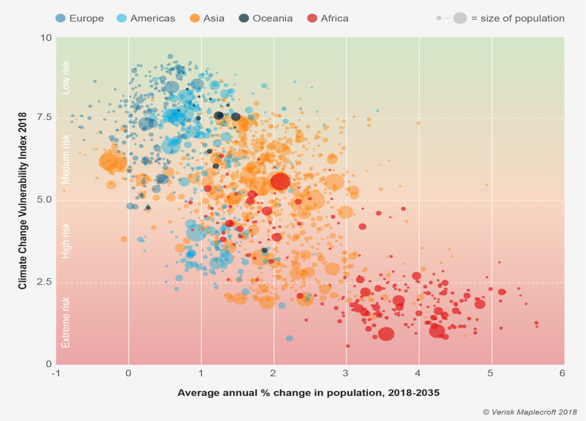

**Week 10: Business Insights and Conclusion**

* Interpret analysis findings in the context of project objectives.
* Derive valuable business intelligence and recommendations.
* Prepare a summary report of insights and project outcomes.
* Conduct a project review and evaluation.

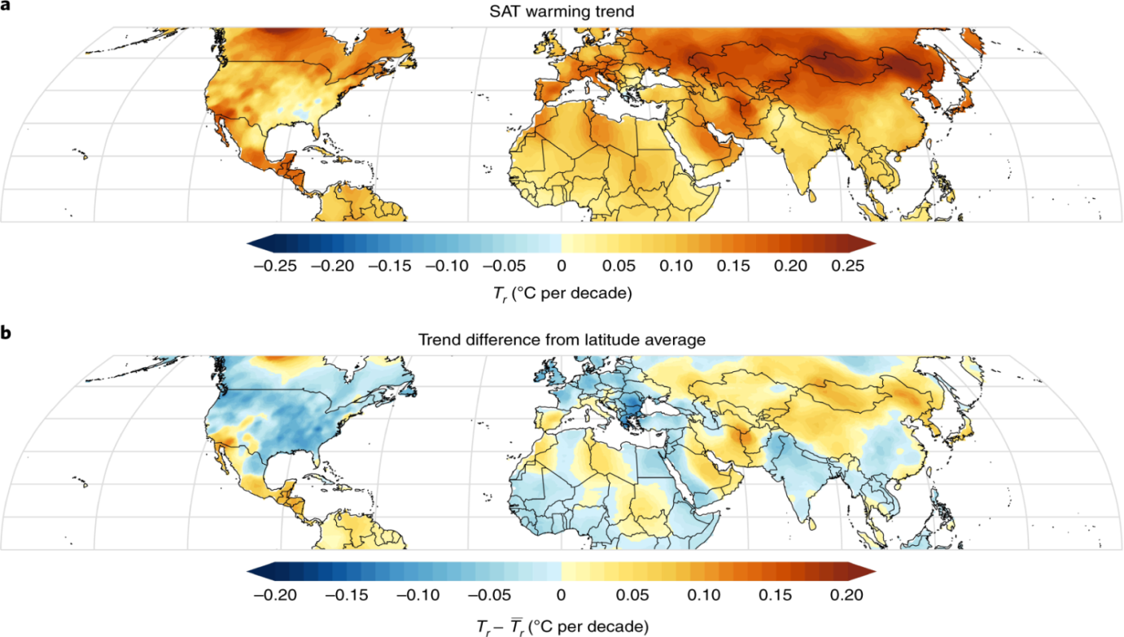

**Goals:**

**1. Effective Data Selection:** Identify and select datasets that are highly relevant to the project's objectives, ensuring that they are of high quality, up-to-date, and representative of the phenomena being investigated.

**2. Efficient Database Setup**: Establish IBM Cloud Databases with optimal security measures, scalability, and performance, tailored to the specific requirements of the project.

**3. Thorough Data Exploration:** Develop comprehensive data exploration processes to gain a deep understanding of the datasets, including data profiling and metadata collection.

**4. Accurate Analysis:** Implement appropriate analysis techniques that are aligned with project goals, resulting in accurate and meaningful insights.

**5. Compelling Visualization:** Create visually engaging and informative data visualizations that cater to the needs of both technical and non-technical stakeholders.

**Benefits:**

**Informed Decision-Making:** By extracting valuable insights from extensive datasets, organizations can make data-driven decisions, leading to more effective strategies, optimized operations, and improved outcomes.

**Efficiency Improvement:** Efficient data management and analysis processes, supported by IBM Cloud Databases, can result in cost savings and operational efficiencies.

**Competitive Advantage:** Organizations that harness the power of big data analytics gain a competitive edge by responding faster to market trends, customer preferences, and emerging opportunities.

**Potential Impact:**

**Improved Environmental Policy:** Climate trend analysis can contribute to informed environmental policies, helping governments and organizations address climate change and its impacts more effectively.

**Business Growth:** Data-driven insights can lead to revenue growth and expansion opportunities for businesses across various industries.

**Societal Benefits:** The project can lead to societal benefits by providing insights into social patterns that can inform public policy, healthcare strategies, and social interventions.

**Potential challenges and risks:**

**1. Data Quality and Availability:**

**Challenge:** Ensuring that the selected datasets are of high quality and up-to-date can be challenging. Data may contain errors, missing values, or inconsistencies.

**Risk:** Poor data quality can lead to inaccurate analysis results and unreliable insights.

**2. Data Security and Privacy:**

**Challenge:** Managing data security and privacy, especially when dealing with sensitive or personally identifiable information (PII), is complex and requires careful handling.

**Risk:** Data breaches or privacy violations can result in legal and reputational consequences.

**3. Visualization Complexity:**

**Challenge:** Designing effective and meaningful visualizations can be challenging, particularly when dealing with complex datasets.

**Risk:** Poorly designed visualizations may fail to convey insights effectively.

**Selected Dataset:**

A dataset of annual surface temperature comprises records of average temperature measurements across different geographic regions, gathered at regular yearly intervals. It typically includes information like location coordinates, date, and corresponding temperature values. This dataset is vital for climate scientists, environmental researchers, and policymakers to assess long-term temperature trends, monitor climate change, and make data-driven decisions in fields such as agriculture, energy, and urban planning. It offers insights into variations in temperature patterns, helping us comprehend the Earth's changing climate and its consequences on ecosystems, weather patterns, and human activities.

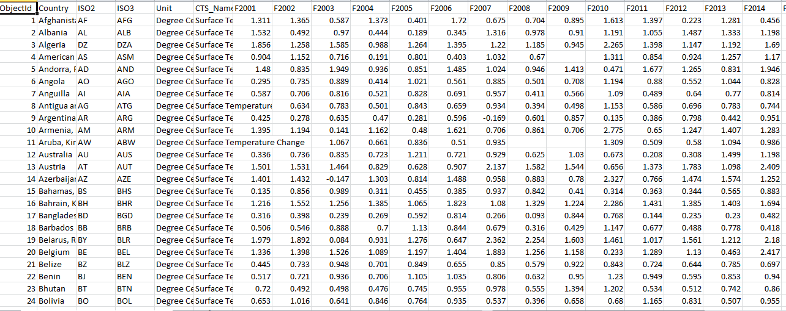

**Data Exploration and Analysis:**

Data exploration and analysis are fundamental processes in the realm of big data. In a landscape defined by vast volumes, high velocities, and diverse data types, effective exploration and analysis techniques are essential. This abstract highlights the crucial role of data exploration and analysis in uncovering actionable insights from massive datasets. It discusses the utilization of cutting-edge tools and methodologies, including machine learning and distributed computing, to reveal hidden patterns and trends. Additionally, it emphasizes the importance of data quality, privacy, and ethical considerations, as the world of big data continues to shape decision-making and innovation across various industries

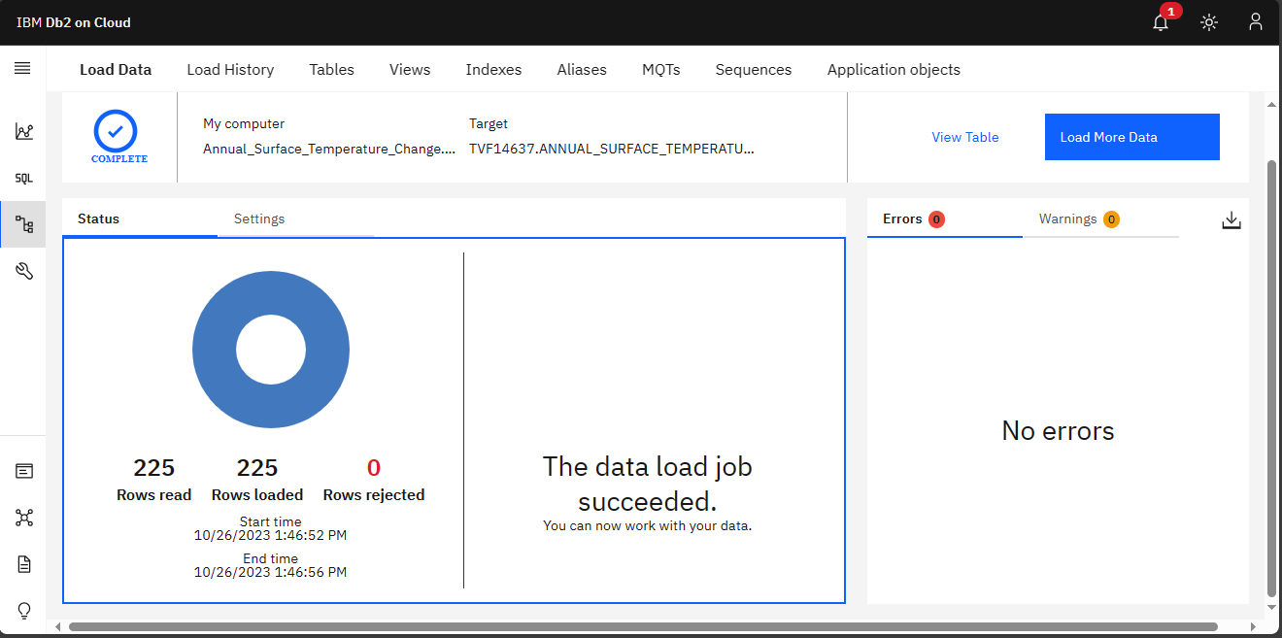

Cleaning a dataset on climate change involves various tasks to ensure the data is accurate and ready for analysis. Below are some example SQL queries that you can use to perform basic cleaning operations on a climate change dataset. Keep in mind that the specific cleaning tasks will depend on the structure of your dataset and the DBMS you are using. You may need to adapt these queries to your dataset's structure.

**1. Remove Duplicates:**

To remove duplicate rows from the dataset.

DELETE FROM Annual_Surface_Temperature_Change

WHERE ROWID NOT IN (

SELECT MIN (ROWID)

FROM Annual_Surface_Temperature_Change

GROUP BY OBJECTID, COUNTRY, ISO2, ISO3, INDICATOR

);

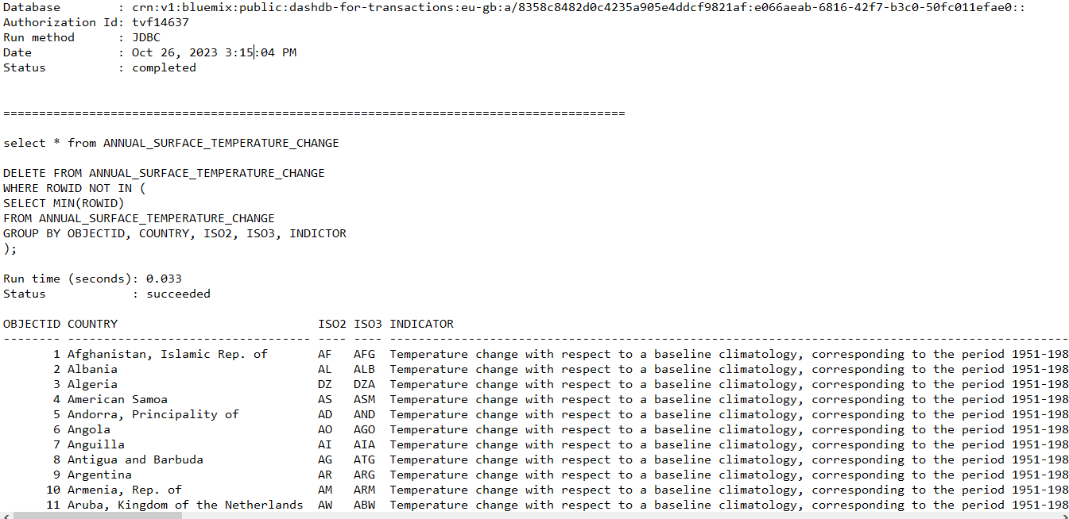

**2. Missing Values:**

To delete rows with missing values:

DELETE FROM Annual_Surface_Temperature_Change

WHERE UNIT IS NULL;

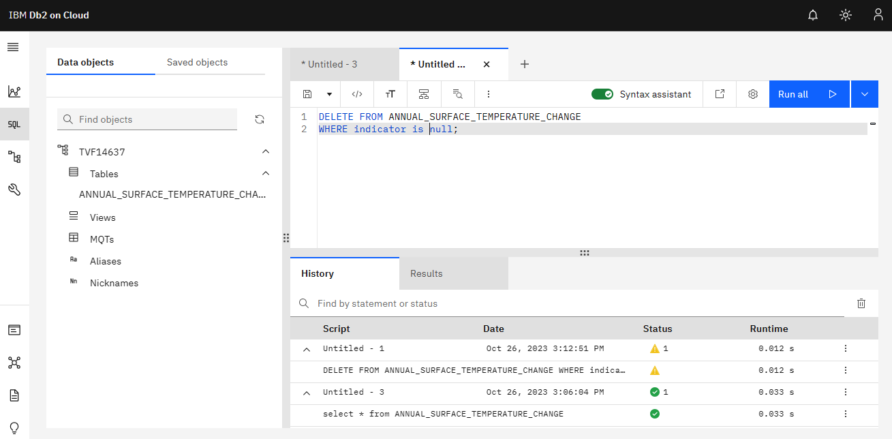

**3. Data Type Conversion:**

Ensure that columns have the correct data types.

ALTER TABLE Annual_Surface_Temperature_Changelimate_data

ALTER COLUMN F2001 TYPE DATE;

ALTER TABLE Annual_Surface_Temperature_Change

ALTER COLUMN F2001 TYPE NUMERIC;

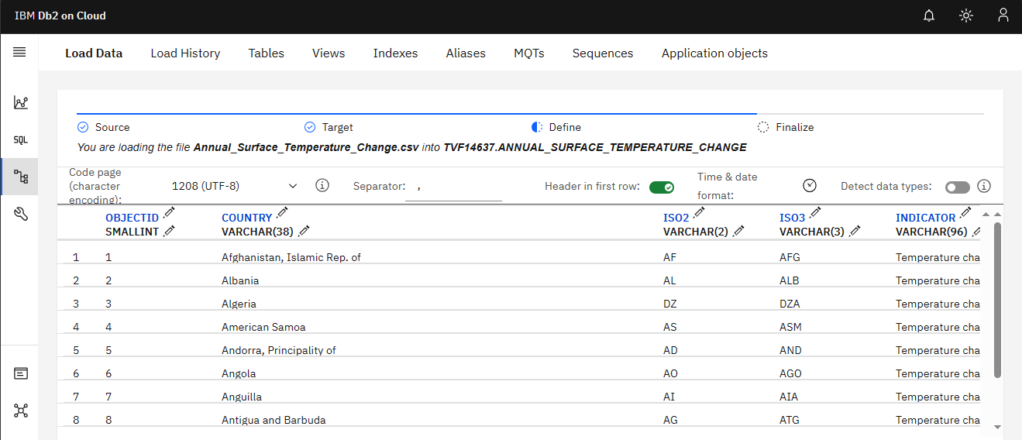

**4. Data Aggregation:**

If your data includes time series data, you might want to aggregate it to a coarser level (e.g., monthly or yearly) for analysis.

SELECT YEAR (F2001 TO F2022)

FROM Annual_Surface_Temperature_Change

GROUP BY YEAR (2001 TO 2022);

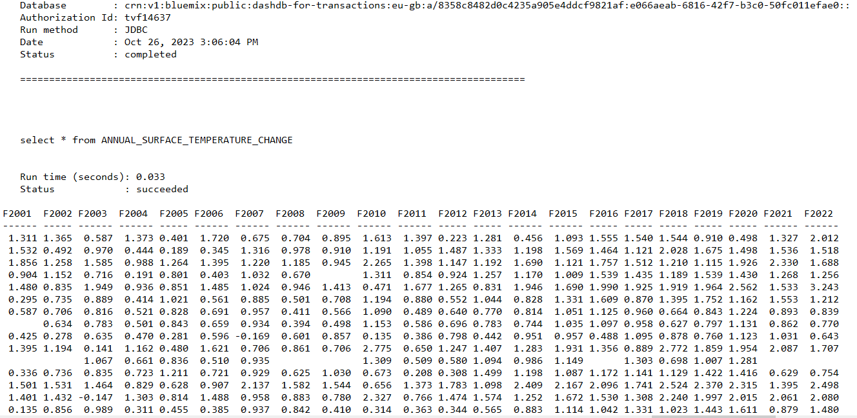

**5. Renaming Columns:**

To make column names more readable:

ALTER TABLE Annual_Surface_Temperature_Change

RENAME COLUMN COUNTRY TO REGION;

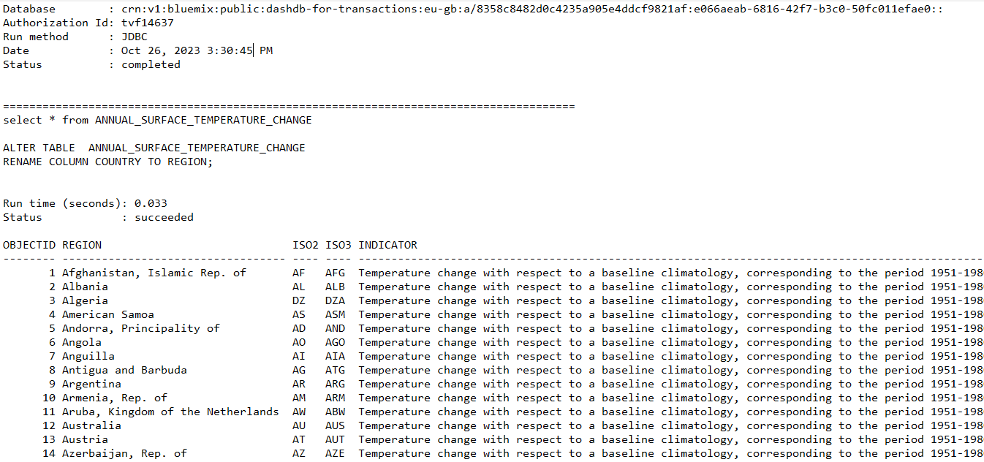

**Advanced Analysis Techniques:**

**Machine Learning Algorithms:**

Machine learning is a subset of artificial intelligence that focuses on developing algorithms capable of learning from and making predictions or decisions based on data. In the context of annual surface temperature datasets, machine learning techniques are employed to model relationships and patterns within the data. These algorithms can be broadly categorized into the following types:

1. **Supervised Learning:**

In supervised learning, the algorithm is trained on a labeled dataset, meaning it learns to map input data (annual temperature records) to corresponding output labels (e.g., temperature values or trends). Common supervised learning algorithms used for temperature analysis include linear regression, decision trees, random forests, and support vector machines.

1. **Unsupervised Learning:**

Unsupervised learning is used to discover patterns and structures in the data without labeled output. Techniques like clustering and dimensionality reduction can be applied to identify temperature clusters, anomalies, or reduce the dataset's complexity.

1. **Time Series Forecasting**:

Temperature data is inherently sequential, making time series forecasting an essential machine learning task. Algorithms such as ARIMA (AutoRegressive Integrated Moving Average), Exponential Smoothing, and more advanced methods like Long Short-Term Memory (LSTM) neural networks are utilized to predict future temperature values based on historical data.

1. **Deep Learning:**

Deep learning, a subset of machine learning, involves neural networks with many layers. Deep learning techniques, including convolutional neural networks (CNNs) and recurrent neural networks (RNNs), are applied to capture complex patterns in spatiotemporal temperature data or for feature extraction.

**Time Series Analysis:**

Time series analysis is a specialized field of statistics and data analysis that focuses on understanding, modeling, and forecasting data that evolves over time. In the case of annual surface temperature datasets, time series analysis entails the following:

**1.Exploratory Data Analysis (EDA):**

EDA involves visualizing and summarizing the data to uncover trends, seasonality, and potential outliers in temperature records. EDA helps in identifying patterns and understanding the underlying structure of the time series.

**2. Decomposition**:

Time series data can be decomposed into three main components: trend, seasonality, and residuals. The trend represents the long-term behaviour, seasonality accounts for recurring patterns, and residuals capture irregular variations. Decomposition is essential for separating and analysing these components.

**3. Forecasting:**

Time series forecasting aims to predict future temperature values based on historical observations. A wide range of models can be employed, from simple methods like exponential smoothing and ARIMA to more complex ones like state-space models and machine learning algorithms.

**4. Anomaly Detection:**

Identifying anomalies or outliers in temperature data is critical for monitoring and addressing unusual or extreme temperature events. Time series analysis can help in flagging unusual temperature spikes or drops.

In summary, machine learning algorithms and time series analysis techniques are indispensable tools for comprehensively analysing annual surface temperature datasets. They allow us to model temperature patterns, make predictions, and gain insights that are valuable for various applications, including climate science, agriculture, and energy management. These techniques help us extract meaningful information from the wealth of temporal temperature data available.

Applying more complex analysis techniques to a dataset of annual surface temperatures typically involves time series analysis and predictive modeling.

**Install necessary python package files:**

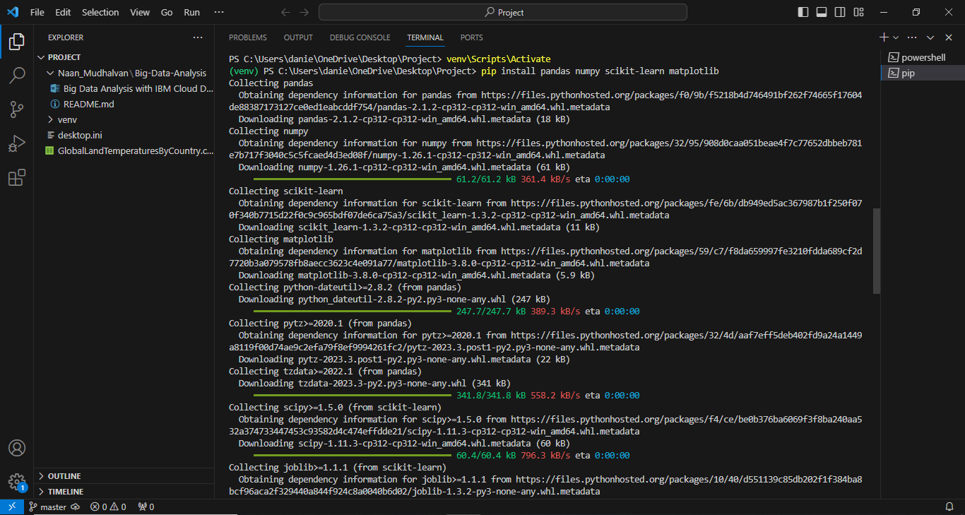

**Step 1:** **Data Preparation**

import pandas as pd

import numpy as np

import matplotlib.pyplot as plt

Import seaborn as sns

#Load the GlobalLandTemparatureyCountry dataset

data=pd.read_csv(‘GlobalLandTemparatureyCountry.csv’)

#Explore the data

print(data.head())

print(data.info())

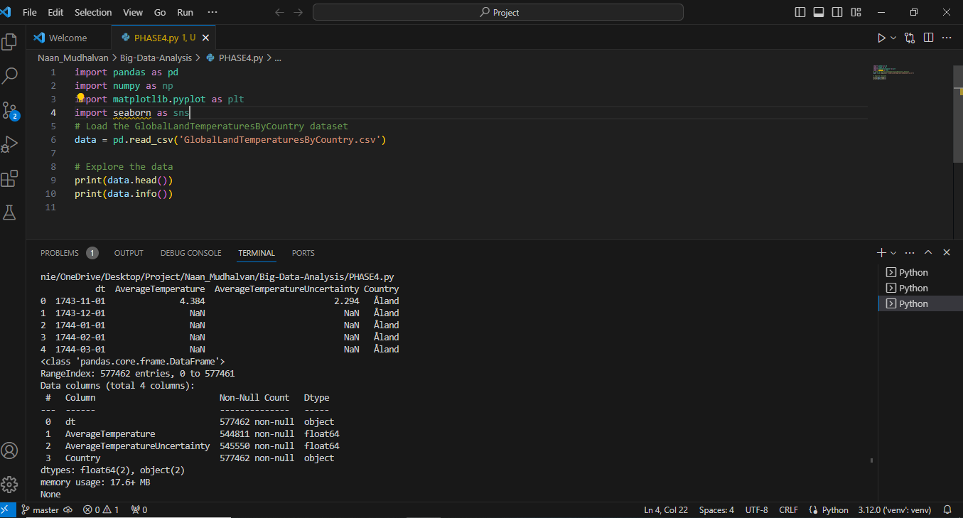

**Step 2: Time Series Analysis**

Time series analysis can help identify trends, seasonality, and perform forecasting. Below is a simplified example of performing a decomposition and visualization of the data.

import statsmodels.api as sm

import matplotlib.pyplot as plt

#Load the GlobalLandTemparatureyCountry dataset

data=pd.read_csv(‘GlobalLandTemparatureyCountry.csv’)

# Decompose the time series data

decomposition = sm.tsa.seasonal_decompose(data['Temperature'], model='additive')

trend = decomposition.trend

seasonal = decomposition.seasonal

residual = decomposition.resid

# Plot the decomposed components

plt.figure(figsize=(12, 6))

plt.subplot(411)

plt.plot(data['Temperature'], label='Original')

plt.legend(loc='upper left')

plt.subplot(412)

plt.plot(trend, label='Trend')

plt.legend(loc='upper left')

plt.subplot(413)

plt.plot(seasonal, label='Seasonal')

plt.legend(loc='upper left')

plt.subplot(414)

plt.plot(residual, label='Residual')

plt.legend(loc='upper left')

plt.tight_layout()

plt.show()

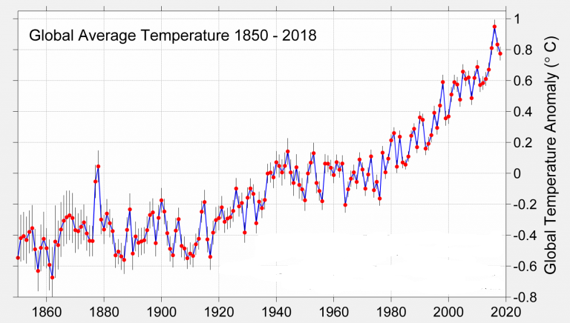

**Step 3: Machine Learning (Regression)**

You can also use machine learning for predictive modeling. Let's use a regression model to predict future temperatures based on historical data.

from sklearn.model_selection import train_test_split

from sklearn.linear_model import LinearRegression

from sklearn.metrics import mean_squared_error, r2_score

# Prepare data for machine learning

data['Year'] = data.index.year

X = data[['Year']]

y = data['Temperature']

# Split data into training and testing sets

X_train, X_test, y_train, y_test = train_test_split(X, y, test_size=0.2, random_state=42)

# Train a linear regression model

model = LinearRegression()

model.fit(X_train, y_train)

# Make predictions

y_pred = model.predict(X_test)

# Evaluate the model

mse = mean_squared_error(y_test, y_pred)

r2 = r2_score(y_test, y_pred)

print(f'Mean Squared Error: {mse}')

print(f'R-squared: {r2}')

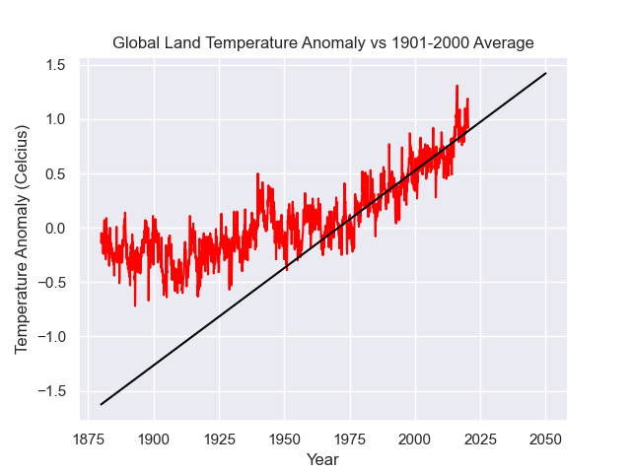

This code provides a simplified example of time series analysis and predictive modeling. In practice, you would explore more sophisticated time series models, feature engineering, and hyperparameter tuning for machine learning models to achieve better results. Additionally, you might want to consider advanced techniques like ARIMA, LSTM, or Prophet for time series analysis.

**Visualization:**

Visualizations are essential for showcasing analysis results and understanding data. Matplotlib and Plotly are popular Python libraries for creating various types of graphs and charts

**Using Matplotlib:**

Matplotlib is a powerful Python library for creating static visualizations. You can create various types of plots, including line plots, bar charts, and histograms.

import matplotlib.pyplot as plt

# With 'Year' and 'Temperature' columns

# Line plot of annual temperature trends

plt.figure(figsize=(12, 6))

plt.plot(df['Year'], df['Temperature'], marker='o', linestyle='-', color='b')

plt.title('Annual Surface Temperature Over Time')

plt.xlabel('Year')

plt.ylabel('Temperature (°C)')

plt.grid(True)

plt.show()

# Histogram of temperature distribution

plt.figure(figsize=(10, 6))

plt.hist(df['Temperature'], bins=20, color='g', alpha=0.7)

plt.title('Temperature Distribution')

plt.xlabel('Temperature (°C)')

plt.ylabel('Frequency')

plt.grid(True)

plt.show()

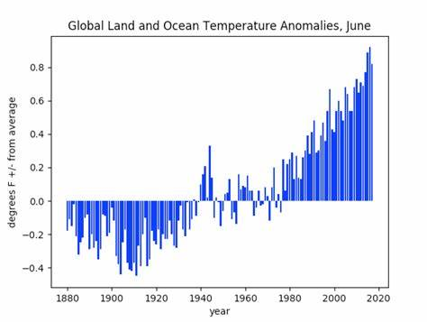

**Using Plotly:**

Plotly is an interactive plotting library that allows for creating interactive and dynamic visualizations. It is particularly useful when you want to explore data and analyse it interactively.

import plotly.express as px

# Create a line plot using Plotly

fig = px.line(df, x='Year', y='Temperature', title='Annual Surface Temperature Over Time')

fig.update_xaxes(title='Year')

fig.update_yaxes(title='Temperature (°C)')

fig.show()

# Create a histogram using Plotly

fig = px.histogram(df, x='Temperature', title='Temperature Distribution')

fig.update_xaxes(title='Temperature (°C)')

fig.update_yaxes(title='Frequency')

fig.show()

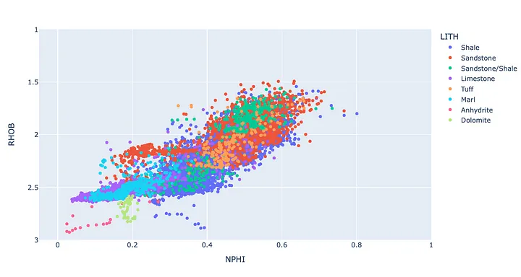

The provided code snippets demonstrate creating a line plot showing annual temperature trends over time and a histogram displaying the distribution of temperatures.

**Business Insights:**

Analysing a dataset of annual surface temperatures using big data techniques can provide valuable business insights that are not only relevant for climate-related industries but also for various sectors that are affected by temperature variations. Here's how the analysis findings can translate into valuable business insights:

**1. Identifying Trends and Patterns:**

Big data analysis can uncover long-term trends and patterns in annual surface temperatures. For instance, it can reveal if temperatures are consistently rising or if there are seasonal variations. This information can be crucial for industries like agriculture and tourism that rely heavily on weather conditions.

**2. Predictive Insights:**

Analyzing historical temperature data can be used to develop predictive models. These models can forecast future temperature trends, enabling businesses to plan accordingly. For example, energy companies can optimize their operations and resource allocation based on temperature forecasts, potentially reducing costs and improving efficiency.

**3. Climate Change Impact Assessment:**

Businesses can assess the impact of climate change on their operations, supply chains, and assets. A rise in annual surface temperatures may affect production, infrastructure, and transportation. By understanding these impacts, companies can develop resilience strategies and adapt to changing conditions.

**4. Resource Allocation:**

Retailers and logistics companies can use temperature data to optimize inventory management. For example, during hot summers, they may stock more cooling products or adjust delivery schedules to account for extreme temperatures.

**5. Environmental Sustainability:**

Companies can use temperature data to measure their carbon footprint and evaluate their sustainability efforts. Understanding the relationship between their activities and local temperature variations can help them make informed decisions about reducing emissions and minimizing environmental impact.

**6. Risk Mitigation:**

Insurance companies can use temperature data to assess and price climate-related risks accurately. This information allows them to offer insurance policies that protect against losses caused by extreme weather events, which may become more common due to rising temperatures.

**7. Marketing and Product Development:**

Consumer-oriented businesses can tailor their marketing and product development strategies based on temperature data. For example, clothing retailers can promote seasonal clothing collections, and food and beverage companies can adjust their product offerings to match weather-related preferences.

**8. Energy Management:**

Big data analysis of temperature data can help energy companies optimize energy production and distribution. They can adjust energy generation strategies based on anticipated temperature fluctuations to ensure reliable energy supply.

**9. Infrastructure Planning:**

Construction and real estate industries can use temperature data to make informed decisions about building design and materials, especially in areas prone to temperature extremes. This can lead to energy-efficient building designs and reduced maintenance costs.

**10. Government and Policy:**

Governments and policymakers can make data-driven decisions on climate change mitigation and adaptation strategies. They can allocate resources, develop regulations, and incentivize businesses to reduce their environmental impact based on temperature data insights.

In summary, analyzing annual surface temperature data with big data techniques can provide valuable insights across a wide range of industries. These insights enable businesses to make informed decisions, mitigate risks, reduce costs, and adapt to the challenges and opportunities presented by changing climate conditions.

**Instructions to Perform analysis in IBM Cloud Databases:**

Deploying a big data analysis solution using IBM Cloud Databases involves several steps, including provisioning a database, loading data, configuring analytical tools, and performing data analysis. Here are the general steps to get you started:

**1. Sign Up for IBM Cloud:**

If you haven't already, sign up for an IBM Cloud account. You may need to provide payment information, but IBM often offers free tiers or trial periods for various services.

**2. Log In to IBM Cloud:**

Log in to your IBM Cloud account using your credentials.

**3. Choose a Database Service:**

IBM Cloud offers several database services, including Db2, Cloudant, and others. Choose the one that best suits your needs. You can find the database services under the "Databases" section in the IBM Cloud catalog.

**4. Provision a Database:**

After selecting a database service, provision a database instance. You'll need to provide configuration details such as database name, region, and resource plan. Depending on your use case, you can choose between SQL or NoSQL databases.

**5. Secure Your Database:**

Configure security settings for your database. Ensure that your database is only accessible to authorized users. This may include setting up firewall rules, access control, and authentication methods.

**6. Load Data:**

To perform data analysis, you'll need data. You can load data into your database using various methods, such as importing CSV files, connecting to data sources, or using ETL (Extract, Transform, Load) tools. Make sure to organize your data properly.

**7. Choose Analytical Tools:**

Select the analytical tools you want to use for data analysis. Common options include IBM Watson Studio, Jupyter Notebooks, or any other tool that fits your needs.

**8. Connect Your Analytical Tools to the Database:**

Configure your analytical tools to connect to your IBM Cloud Database. You'll typically need to provide connection details, including the database endpoint, credentials, and connection method.

**9. Perform Data Analysis:**

Use your chosen analytical tools to perform data analysis. You can write SQL queries or use data analysis libraries like Pandas, NumPy, or Spark to extract insights from your data.

**10. Visualize Results:**

After performing data analysis, you may want to create data visualizations to help you and others understand the insights you've gained. Tools like Matplotlib, Seaborn, Tableau, or Power BI can help with this.

**11. Optimize and Scale:**

As your data analysis needs grow, you may need to optimize and scale your database and analytical tools. IBM Cloud provides options to upgrade your resources or add more instances as needed.

**12. Monitor and Maintain:**

Continuously monitor the performance of your database and analytical tools. Set up alerts for any anomalies or issues and perform regular maintenance tasks like backups and updates.

**13. Share Insights:**

Share your data analysis findings with your team or stakeholders. You can export reports, share dashboards, or collaborate through IBM Cloud services.

**Conclusion:**

The project on "Big Data Analysis with IBM Cloud Databases" aims to extract valuable insights from extensive datasets, fostering informed decision-making and business intelligence. The detailed plan outlines a systematic approach over ten weeks, from project initiation to insights generation. Benefits include improved efficiency, competitive advantage, and societal impacts. However, challenges like data quality and security must be managed. By executing this plan effectively, organizations can harness the power of data analytics to drive growth, innovation, and informed environmental policies, while addressing potential risks to ensure reliable outcomes.